实验1:回归模型

曾令泽 1120162062

## 线性回归模型 Linear Regression

代码：

#!/usr/bin/env python3

# -*- coding: utf-8 -*-

"""

Created on Sat Mar 30 19:31:39 2019

@author: e1ixir

"""

import numpy as np

import pandas as pd

from sklearn.linear_model import LinearRegression,Ridge,Lasso,\

LogisticRegression,ElasticNet

from sklearn.model_selection import train_test_split

from sklearn.datasets import fetch_california_housing,\

fetch_20newsgroups_vectorized

from sklearn.datasets import make_regression

from sklearn.metrics import mean_squared_error,mean_absolute_error,r2_score

def evalue(model,y_test,x_test):

y_predict=model.predict(x_test)

mse=mean_squared_error(y_test,y_predict)

mae=mean_absolute_error(y_test,y_predict)

score=model.score(x_test,y_test)

r2score=r2_score(y_test,y_predict)

print("mse:{} \t mae:{}\t score:{}\t r2_score:{}\n"\

.format(mse,mae,score,r2score))

# 导入房价数据

data=fetch_california_housing()

data_x=data.data

data_y=data.target

feature=data.feature_names

#分割训练数据集

x_train,x_test,y_train,y_test=train_test_split(data_x,data_y,test_size=0.2,random_state=1)

#定义模型

lr=LinearRegression()

#l_ridge=Ridge(alpha=1.0)

#l_lasso=Lasso(alpha=0.1)

#l_elas=ElasticNet(random_state=0)

#训练模型（只进行了一次迭代）

lr.fit(x_train,y_train)

#l_ridge.fit(x_train,y_train)

#l_lasso.fit(x_train,y_train)

#l_elas.fit(x_train,y_train)

#打印训练结果

evalue(lr,y_test,x_test)

#evalue(l_ridge,y_test,x_test)

#evalue(l_lasso,y_test,x_test)

#evalue(l_elas,y_test,x_test)

实验结果：

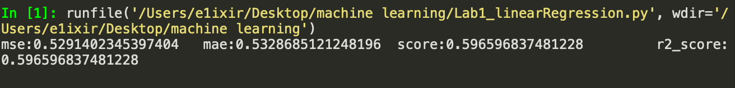

## 岭回归模型 Ridge Regression

#!/usr/bin/env python3

# -*- coding: utf-8 -*-

"""

Created on Sat Mar 30 19:39:08 2019

@author: e1ixir

"""

import numpy as np

import pandas as pd

from sklearn.linear_model import LinearRegression,Ridge,Lasso,\

LogisticRegression,ElasticNet

from sklearn.model_selection import train_test_split

from sklearn.datasets import fetch_california_housing,\

fetch_20newsgroups_vectorized

from sklearn.datasets import make_regression

from sklearn.metrics import mean_squared_error,mean_absolute_error,r2_score

def evalue(model,y_test,x_test):

y_predict=model.predict(x_test)

mse=mean_squared_error(y_test,y_predict)

mae=mean_absolute_error(y_test,y_predict)

score=model.score(x_test,y_test)

r2score=r2_score(y_test,y_predict)

print("mse:{} \t mae:{}\t score:{}\t r2_score:{}\n"\

.format(mse,mae,score,r2score))

# =============================================================================

# 导入房价数据

# =============================================================================

data=fetch_california_housing()

data_x=data.data

data_y=data.target

feature=data.feature_names

# =============================================================================

# 分割训练数据集

# =============================================================================

x_train,x_test,y_train,y_test=train_test_split(data_x,data_y,test_size=0.2,random_state=1)

# =============================================================================

# 定义模型

# =============================================================================

#lr=LinearRegression()

l_ridge=Ridge(alpha=1.0)

#l_lasso=Lasso(alpha=0.1)

#l_elas=ElasticNet(random_state=0)

# =============================================================================

# 训练模型（只进行了一次迭代）

# =============================================================================

#lr.fit(x_train,y_train)

l_ridge.fit(x_train,y_train)

#l_lasso.fit(x_train,y_train)

#l_elas.fit(x_train,y_train)

# =============================================================================

# 打印训练测试结果

# =============================================================================

#evalue(lr,y_test,x_test)

evalue(l_ridge,y_test,x_test)

#evalue(l_lasso,y_test,x_test)

#evalue(l_elas,y_test,x_test)

实验结果：

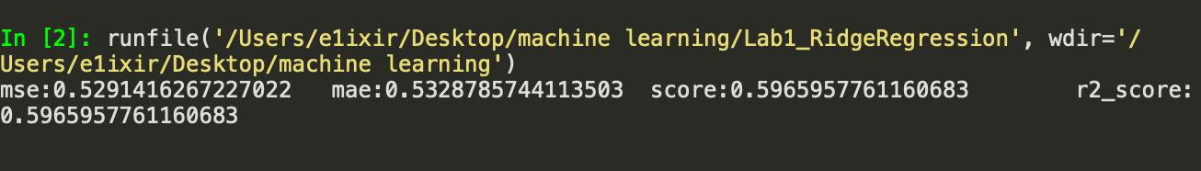

## 套索回归模型 Lasso Regression+GridSearch

代码：

#!/usr/bin/env python3

# -*- coding: utf-8 -*-

"""

Created on Sat Mar 30 19:42:32 2019

@author: e1ixir

"""

import numpy as np

import pandas as pd

from sklearn.linear_model import LinearRegression,Ridge,Lasso,\

LogisticRegression,ElasticNet

from sklearn.model_selection import train_test_split

from sklearn.datasets import fetch_california_housing,\

fetch_20newsgroups_vectorized

from sklearn.datasets import make_regression

from sklearn.metrics import mean_squared_error,mean_absolute_error,r2_score

def evalue(model,y_test,x_test):

y_predict=model.predict(x_test)

mse=mean_squared_error(y_test,y_predict)

mae=mean_absolute_error(y_test,y_predict)

score=model.score(x_test,y_test)

r2score=r2_score(y_test,y_predict)

print("mse:{} \t mae:{}\t score:{}\t r2_score:{}\n"\

.format(mse,mae,score,r2score))

# =============================================================================

# 导入房价数据

# =============================================================================

data=fetch_california_housing()

data_x=data.data

data_y=data.target

feature=data.feature_names

# =============================================================================

# 分割训练数据集

# =============================================================================

x_train,x_test,y_train,y_test=train_test_split(data_x,data_y,test_size=0.2,random_state=1)

# =============================================================================

# 参数调优

# =============================================================================

from sklearn.model_selection import GridSearchCV

parameter={"alpha":[0.1,0.5,1.0,0.05],"max_iter":[100,500,1000,50]}

#损失函数中的alpha 选择和最大迭代次数

clf=GridSearchCV(Lasso(),parameter,cv=5)

#5折交叉验证

# =============================================================================

# 训练模型（

# =============================================================================

clf.fit(x_train,y_train)

# =============================================================================

# 打印训练测试结果

# =============================================================================

# 自动参数调优结果

print("best params:{}".format(clf.best_params_))

#测试结果

evalue(clf,y_test,x_test)

实验结果：

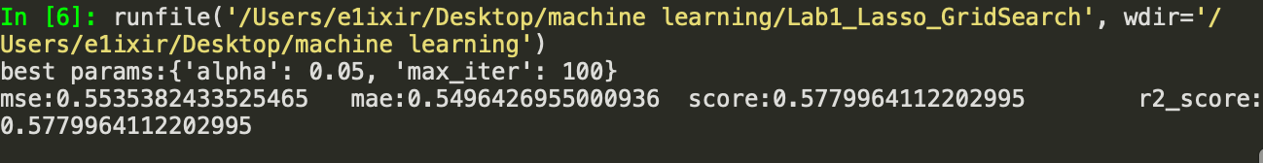

## 弹性网回归模型 ElasticNet Regression

代码：

#!/usr/bin/env python3

# -*- coding: utf-8 -*-

"""

Created on Sat Mar 30 19:41:30 2019

@author: e1ixir

"""

import numpy as np

import pandas as pd

from sklearn.linear_model import LinearRegression,Ridge,Lasso,\

LogisticRegression,ElasticNet

from sklearn.model_selection import train_test_split

from sklearn.datasets import fetch_california_housing,\

fetch_20newsgroups_vectorized

from sklearn.datasets import make_regression

from sklearn.metrics import mean_squared_error,mean_absolute_error,r2_score

def evalue(model,y_test,x_test):

y_predict=model.predict(x_test)

mse=mean_squared_error(y_test,y_predict)

mae=mean_absolute_error(y_test,y_predict)

score=model.score(x_test,y_test)

r2score=r2_score(y_test,y_predict)

print("mse:{} \t mae:{}\t score:{}\t r2_score:{}\n"\

.format(mse,mae,score,r2score))

# =============================================================================

# 导入房价数据

# =============================================================================

data=fetch_california_housing()

data_x=data.data

data_y=data.target

feature=data.feature_names

# =============================================================================

# 分割训练数据集

# =============================================================================

x_train,x_test,y_train,y_test=train_test_split(data_x,data_y,test_size=0.2,random_state=1)

# =============================================================================

# 定义模型

# =============================================================================

#lr=LinearRegression()

#l_ridge=Ridge(alpha=1.0)

#l_lasso=Lasso(alpha=0.1)

l_elas=ElasticNet(random_state=0)

# =============================================================================

# 训练模型（只进行了一次迭代）

# =============================================================================

#lr.fit(x_train,y_train)

#l_ridge.fit(x_train,y_train)

#l_lasso.fit(x_train,y_train)

l_elas.fit(x_train,y_train)

# =============================================================================

# 打印训练测试结果

# =============================================================================

#evalue(lr,y_test,x_test)

#evalue(l_ridge,y_test,x_test)

#evalue(l_lasso,y_test,x_test)

evalue(l_elas,y_test,x_test)

实验结果：

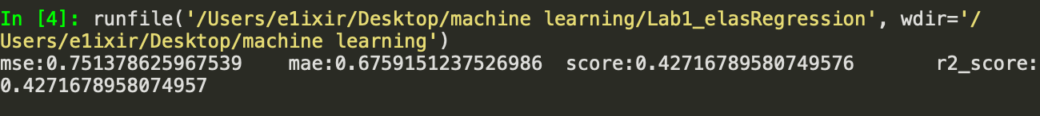

## 逻辑回归模型 Logistic Regression

#!/usr/bin/env python3

# -*- coding: utf-8 -*-

"""

Created on Sat Mar 30 19:48:58 2019

@author: e1ixir

"""

import numpy as np

import pandas as pd

from sklearn.linear_model import LinearRegression,Ridge,Lasso,\

LogisticRegression,ElasticNet

from sklearn.model_selection import train_test_split

from sklearn.datasets import fetch_california_housing,\

fetch_20newsgroups_vectorized

from sklearn.datasets import make_regression

from sklearn.metrics import mean_squared_error,mean_absolute_error,r2_score

def evalue(model,y_test,x_test):

y_predict=model.predict(x_test)

mse=mean_squared_error(y_test,y_predict)

mae=mean_absolute_error(y_test,y_predict)

score=model.score(x_test,y_test)

r2score=r2_score(y_test,y_predict)

print("mse:{} \t mae:{}\t score:{}\t r2_score:{}\n"\

.format(mse,mae,score,r2score))

# =============================================================================

# 导入新闻数据

# =============================================================================

data_logistic=fetch_20newsgroups_vectorized()

data_log_x=data_logistic.data

data_log_y=data_logistic.target

# =============================================================================

# 分割训练数据集

# =============================================================================

x_train,x_test,y_train,y_test=train_test_split(data_log_x,data_log_y,test_size=0.2,random_state=1)

# =============================================================================

# 定义模型

# =============================================================================

logist=LogisticRegression()

# =============================================================================

# 训练模型（只进行了一次迭代）

# =============================================================================

logist.fit(x_train,y_train)

# =============================================================================

# 打印训练测试结果

# =============================================================================

evalue(logist,y_test,x_test)

实验结果：

